**Name - Divyani Khade**

**Batch - 6th Feb Python Fullstack with data science**

**Date - 25th April, 2025**

1. **Output -**

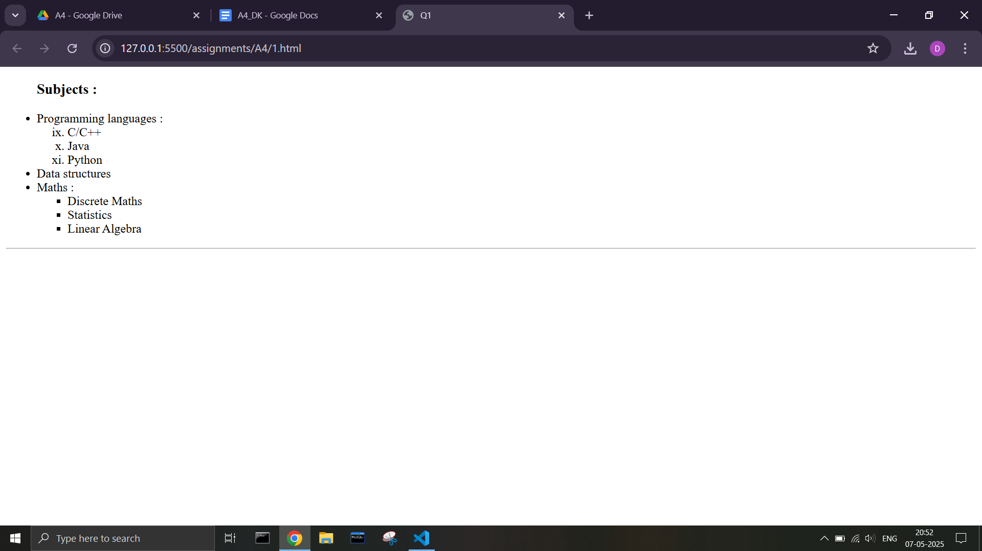

**Code -**

**<!DOCTYPE html>**

**<html lang="en">**

**<head>**

**title>A4-1</title>**

**</head>**

**<body>**

**<ul>**

**<h3>Subjects :</h3>**

**<li>Programming languages :**

**<ol type="i" start="9">**

**<li>C/C++</li>**

**<li>Java</li>**

**<li>Python</li>**

**</ol>**

**</li>**

**<li>Data structures</li>**

**<li>Maths :**

**<ul type="square">**

**<li>Discrete Maths</li>**

**<li>Statistics</li>**

**<li>Linear Algebra</li>**

**</ul>**

**</li>**

**</ul>**

**<hr>**

**</body>**

**</html>**

1. **Output -**

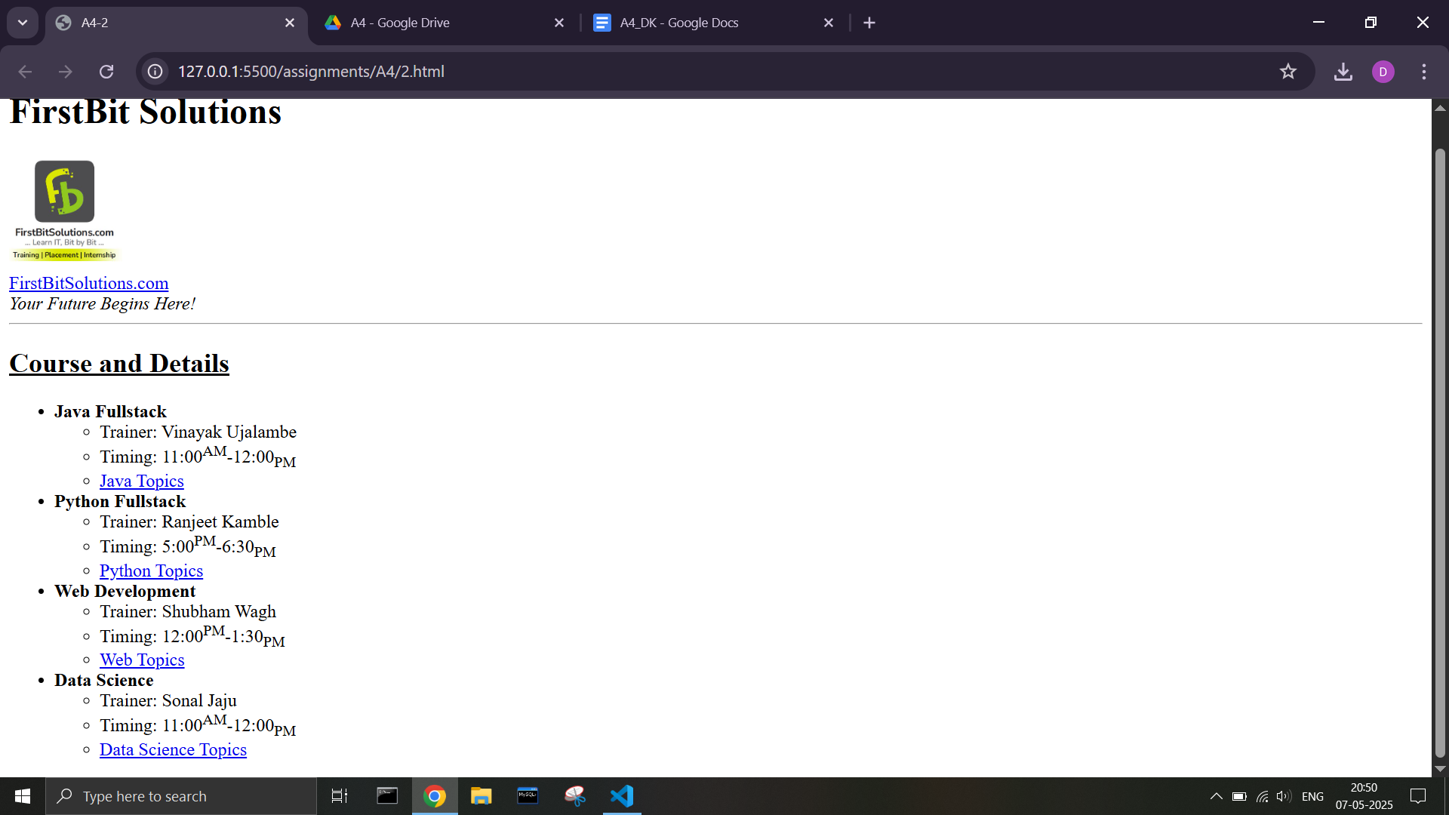

**Code -**

**<!DOCTYPE html>**

**<html lang="en">**

**<head>**

**<meta charset="UTF-8">**

**<meta name="viewport" content="width=device-width, initial-scale=1.0">**

**<title>A4-2</title>**

**</head>**

**<body>**

**<h1>FirstBit Solutions</h1>**

**<img src="https://i.postimg.cc/9FLzZYBS/logo.jpg" height="100" width="100">**

**<br>**

**<a href="https://firstbitsolutions.com">FirstBitSolutions.com</a>**

**<br>**

**<i>Your Future Begins Here!</i>**

**<hr>**

**<h2><u>Course and Details</u></h2>**

**<ul>**

**<li><b>Java Fullstack</b>**

**<ul>**

**<li>Trainer: Vinayak Ujalambe</li>**

**<li>Timing: 11:00<sup>AM</sup>-12:00<sub>PM</sub></li>**

**<li><a href="java_topics.html">Java Topics</a></li>**

**</ul>**

**</li>**

**<li><b>Python Fullstack</b>**

**<ul>**

**<li>Trainer: Ranjeet Kamble</li>**

**<li>Timing: 5:00<sup>PM</sup>-6:30<sub>PM</sub></li>**

**<li><a href="python_topics.html">Python Topics</a></li>**

**</ul>**

**</li>**

**<li><b>Web Development</b>**

**<ul>**

**<li>Trainer: Shubham Wagh</li>**

**<li>Timing: 12:00<sup>PM</sup>-1:30<sub>PM</sub></li>**

**<li><a href="web_topics.html">Web Topics</a></li>**

**</ul>**

**</li>**

**<li><b>Data Science</b>**

**<ul>**

**<li>Trainer: Sonal Jaju</li>**

**<li>Timing: 11:00<sup>AM</sup>-12:00<sub>PM</sub></li>**

**<li><a href="DS_topics.html">Data Science Topics</a></li>**

**</ul>**

**</li>**

**</ul>**

**</body>**

**</html>**